Launch Linux EC2 instances in 2 regions using a single terraform file.

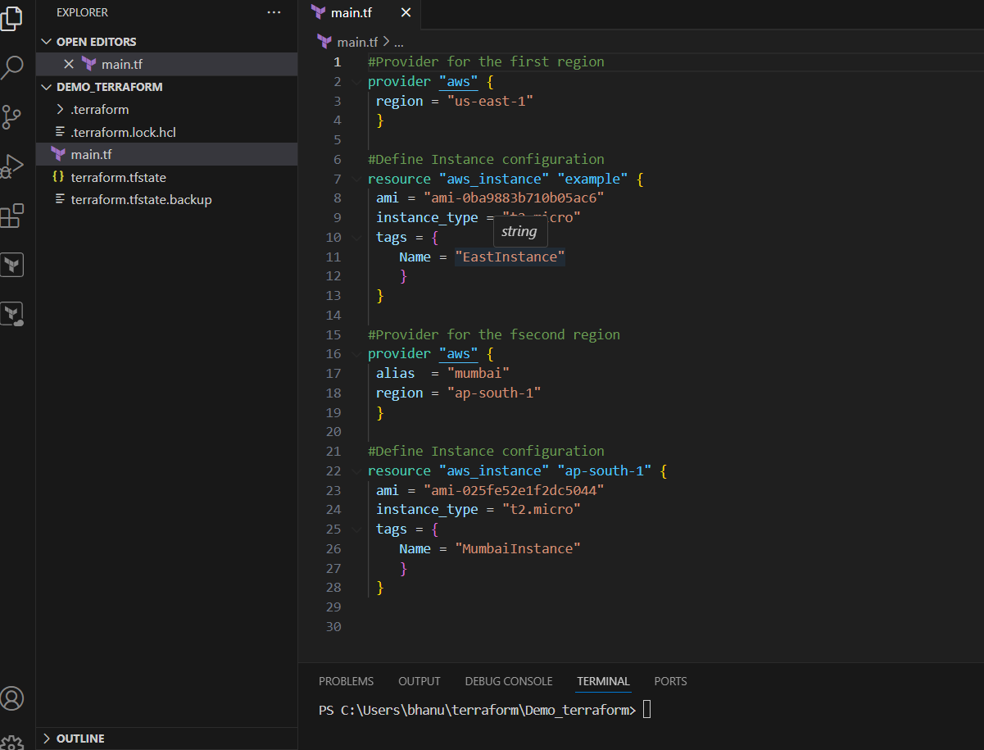

#Provider for the first region

provider "aws" {

 alias  = "us-east"

 region = "us-east-1"

 }

#Define Instance configuration

resource "aws_instance" "us-east-1" {

 provider = aws.us-east

 ami = "ami-0ba9883b710b05ac6"

 instance_type = "t2.micro"

 tags = {

    Name = "EastInstance"

    }

 }

#Provider for the second region

provider "aws" {

 alias = "mumbai"

 region = "ap-south-1"

 }

#Define Instance configuration

resource "aws_instance" "ap-south-1" {

 provider = aws.mumbai

 ami = "ami-025fe52e1f2dc5044"

 instance_type = "t2.micro"

 tags = {

    Name = "MumbaiInstance"

    }

we define two aws_provider blocks, one for the us-east-1 region (aliased as us-east) and another for the ap-south-1 region (aliased as mumbai). We then create two aws_instance resources, one for each region, and specify the corresponding provider attribute.

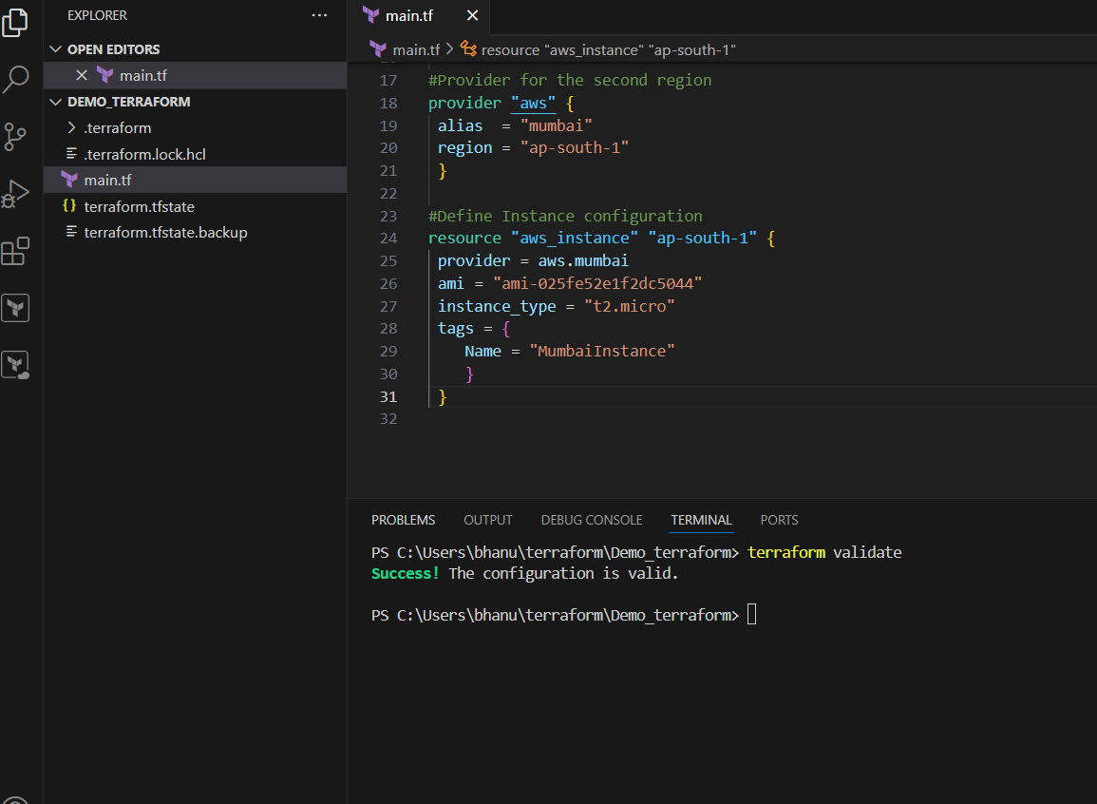

Run terraform apply to launch the instances in both regions. Terraform will create the resources in parallel, using the respective providers for each region.

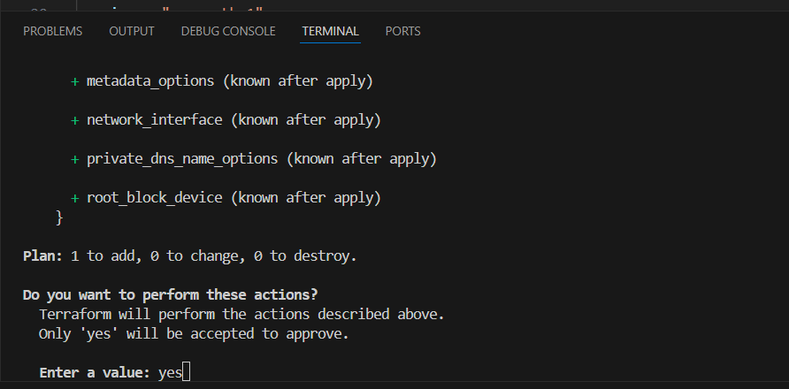

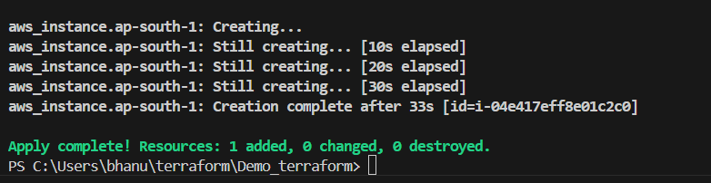

Instance from us-east-1 region is created with tag name as **EastInstance**.

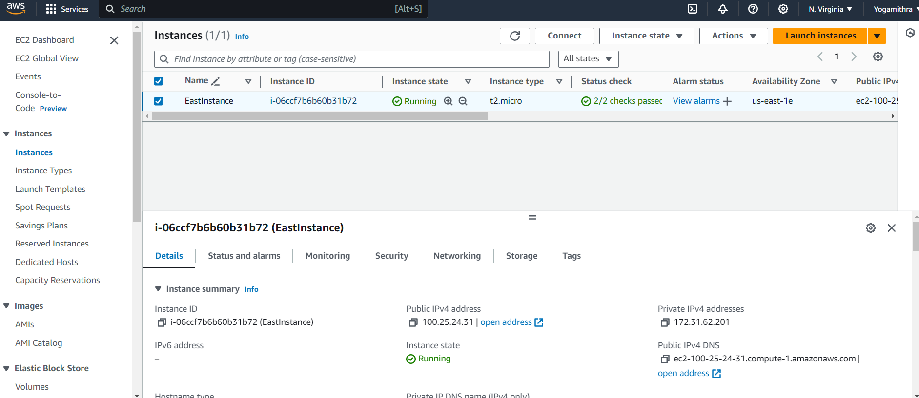

Instance from ap-south-1 region is created with tag name as **MumbaiInstance**.

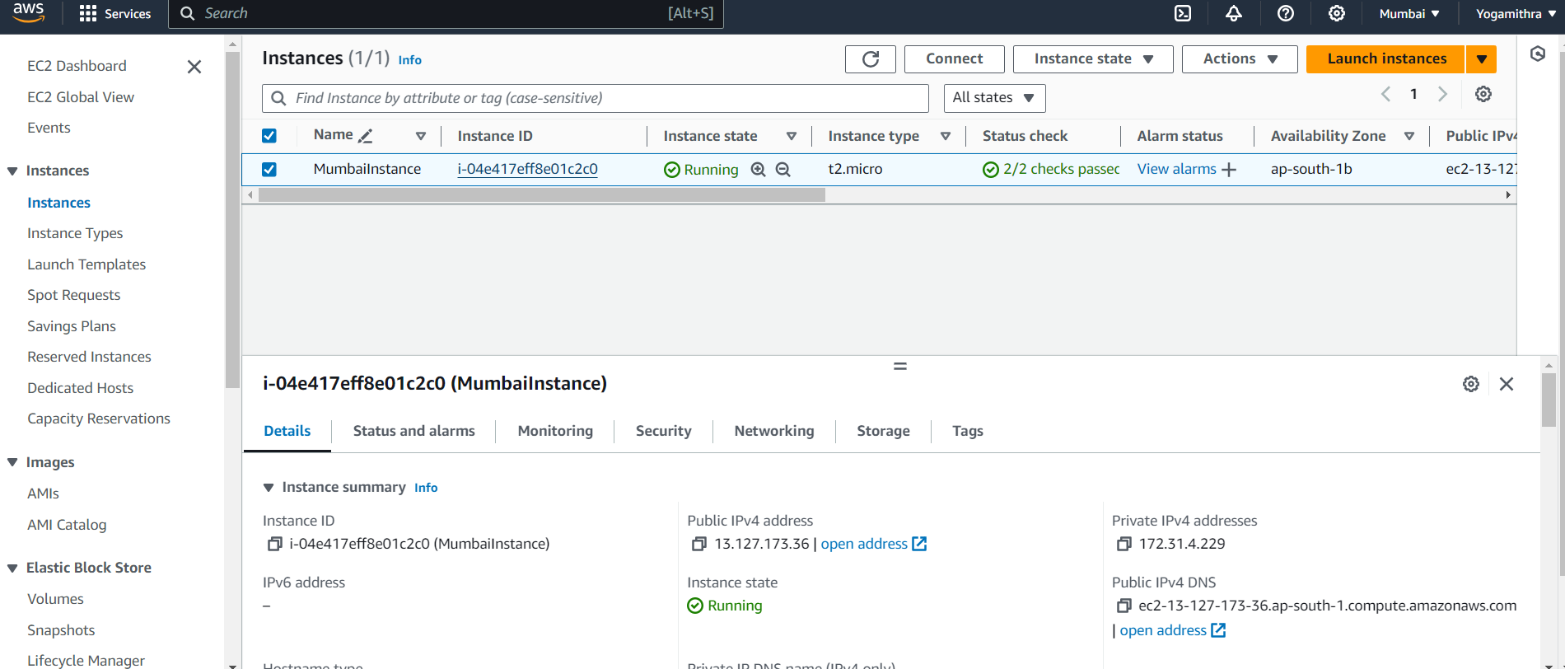

To remove all resources created by Terraform in the current directory.

